Discharge Rate of Aerosol Dispenser
CIPAC Collaborative Trial
CIPAC Information Sheet No 328

German Speaking Working Group for Plant Protection Products (DAPF)

Dipl.-Ing. (FH) Dieter Walter
Physical-Chemical Properties
Eurofins Agroscience Services EcoChem GmbH
Eutinger Str. 24
75223 Niefern-Öschelbronn, Germany

Dr. Claudia Vinke
Bundesamt für Verbraucherschutz und Lebensmittelsicherheit Abteilung Pflanzenschutzmittel Messeweg 11/12
38104 Braunschweig

May 2022

Table of Contents
1 General Information 3
2 List of Participants 4
3 Aerosol Dispenser 5
4. Description of the Method 7
5. Results 9
5.1 Results Schädlingsfrei Careo Orchideen & Zierpflanzen 9
5.2 Results Vorox Unkrautfrei Express AF 12
6 Evaluation of Results 16
6.1 Schädlingsfrei Careo Orchideen & Zierpflanzen 16
6.2 Vorox Unkrautfrei Express AF 16
6.3 Ratio 50 T 17
7 Conclusion and Recommendation 19

1 General Information
A method for determination of the discharge rate of aerosol dispenser was developed within the framework of DAPF* and a full scale collaborative trial was carried out using two different types of aerosol dispenser.
The scope of the method is to measure the discharge rate of aerosol dispenser. Furthermore, the behavior of the spray nozzle and spray head during spraying process should be visually observed and described. The method is applicable for non-lockable aerosol dispensers.

Scope/Aim of the Collaborative Trial
The objective was to evaluate the repeatability and reproducibility of the proposed method for measuring the discharge rate of aerosol dispenser.
10 laboratories from the EU, Switzerland, UK and the US participated in the Round Robin and sent back their results. Shipment to one laboratory in India failed due to customs problem.
The discharge rate of two commercially available aerosol dispenser distributed to the volunteering laboratories were evaluated.
The aerosol dispenser provided for the trial were:
No. | Product | Volume [mL] | Supplier | Active ingredients | Spray mechanism
1 | Spruzit Schädlingsspray | 400 | Neudorff | Pyrethrum/  Rapseed oil | compressed air
2 | Protect Home  Forminex Spezialspray | 200 | SBM Life Science/  Protect Home | Imiprothrin, Cyphenothrin | propellant (Propan/Buten/Isobutan)
The aerosol dispensers were carefully padded and packed to avoid any damage during shipment.

*DAPF = German Speaking Working Group for Plant Protection Products

2 List of Participants

Country | Name | Organisation
Germany | Dr. Thomas Kroehl | BASF SE
Greece | Dr. Elen Karasali | BENAKI Phytopathological Institute, Laboratory of chemical Assessment of Pesticides Scintific Directorate of Pesticides' Assessment and Phytopharmacy
Czech Republic | Dipl.-Ing. Olga Nováková | UKZUZ (CENTRAL INSTITUTE FOR SUPERVISING AND TESTING IN AGRICULTURE)
Suisse | Bruno Patrian | Eidgenössisches Departement für  Wirtschaft, Bildung und Forschung WBF  Agroscope  Kompetenzbereich Pflanzen und pflanzliche Produkte
Germany | Dr. Claudia Vinke | Bundesamt für Verbraucherschutz und Lebensmittelsicherheit
United Kingdom | David Thomas | Smithers ERS Ltd
Belgium | Dr. Ir. Olivier Pigeon/  Pierre Hucorne | Walloon Agricultural Research Centre (CRA-W)
USA | Dr. Oliver Gutsche | FMC
Germany | Dr. Martin Steinbeck | Bayer AG, Division Crop Science
Germany | Dirk Arnold | Eurofins Agroscience Services EcoChem GmbH

The collaborative trial was limited to a maximum of 10 laboratories due to the limited availability of samples. 11 laboratories announced their willingness to participate in the collaborative test. The announcement of one further lab, received after the deadline of 01 June 2021, was refused since the maximum number of participants was reached.
Furthermore, samples could not be shipped to a laboratory located in India since there were problems with import papers which could not be solved.
The samples were dispatched from Germany on 08.06.2021.

9 laboratories received the samples within June 2021.
1 laboratory received the samples delayed 6 months after shipment due to shipment/import problems.
6 laboratories sent their results as planned by 31 August 2021.
Other results were provided at 19 September 2021, 17 December 2021, 07 March 2022 and 28 Apr 2022.

3 Aerosol Dispenser
Test Item 1 | Spruzit Schädlingsspray
 | 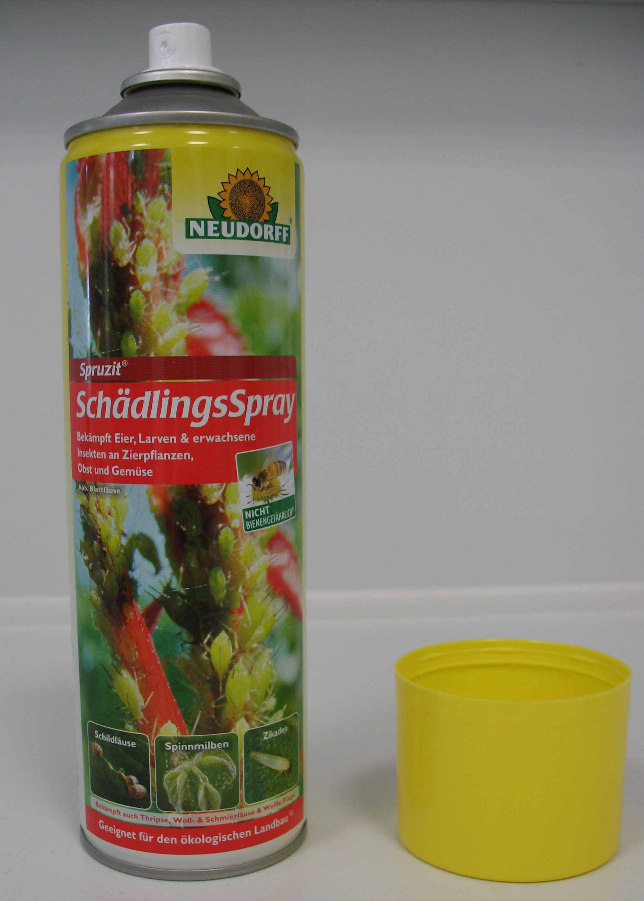
Batch | SP324
Kind of formulation | AE (Aerosol dispenser), 400 mL aerosol can with inner bag,  propellant: compressed air
Active ingredient | Pyrethrum, Rapseed oil

Test Item 2 | Protect Home Forminex Spezialspray
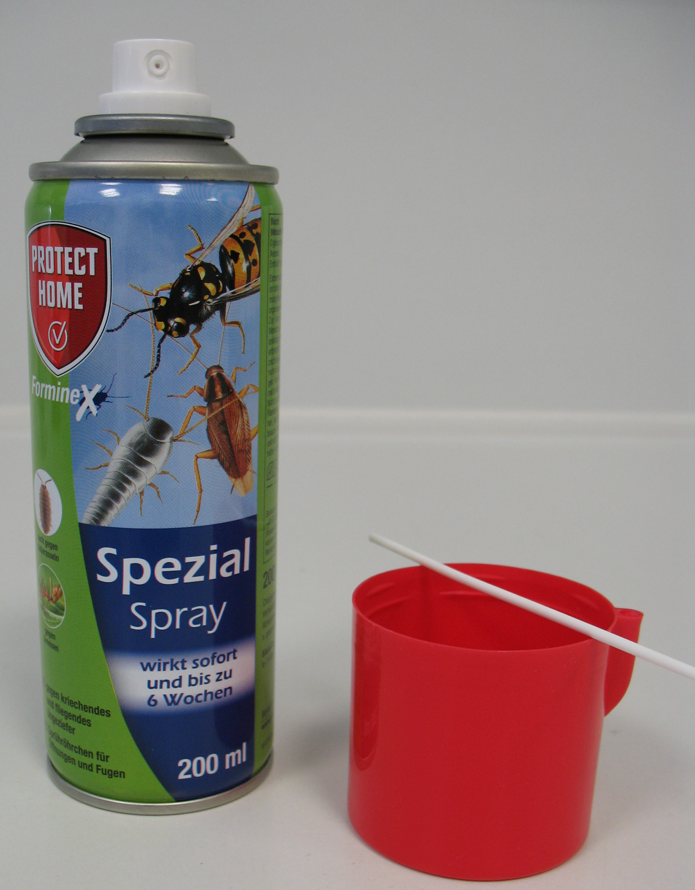
Pipe
Batch | EZT2029513
Kind of formulation | AE (Aerosol dispenser), 200 mL aerosol can,  propellant: propan/butan/isobutan
Active ingredient | Imiprothrin, Cyphenothrin

4. Description of the Method

SCOPE
This method is intended for measuring the discharge rate of aerosol dispensers. During spraying process, the behaviour of the spray nozzle and spray head is observed visually. The method is applicable for non-lockable aerosol dispensers.

OUTLINE OF METHOD
The discharge rate of an aerosol dispenser is determined by measuring the quantity of material expelled through the valve in a given time. The discharge rate is determined at different stages in the emptying of the dispenser.

APPARATUS

Thermometer

Stop watch

Balance, with an accuracy of at least ± 0.1 g

Spray collection chamber, located in a fume hood

Absorbent paper

PROCEDURE
- Preparation of test sample

Equilibrate the aerosol dispenser at ambient temperature (25 ± 5 °C). Weight the aerosol dispenser to the nearest 0.1 g (m_{f} in [g]). Handle the aerosol dispenser according to label instructions. If there is no instruction available shake vigorously for at least 10 s by hand. Operate the valve fully open (Note 1) for 5 s (Note 2) to remove material from the spray mechanism which may not be homogenous with the bulk of the filling.
- Determination of the discharge rate

b.1) Weigh the dispenser (m₁ in [g]).

b.2) Shake the aerosol dispenser for approximately 3 s by hand and afterwards operate the valve fully open (Note 1) for 10 s (Note 2). During the discharge, position the dispenser as indicated in the instructions for use. If no instructions are given, use an upright position for the dispenser.

b.3) Re-weigh the dispenser to the nearest 0.1 g (m₂ in [g]).

Repeat the procedures (b.1) to (b.3) until the dispenser is empty (empty means no liquid or gas is expelled). Use m₂ of the previous measurement as m₁ of the next measurement.
During each spraying process, observe the spray nozzle of the aerosol dispenser. Note disturbances of the spray nozzle as well as any observations of crystallized material on the nozzle, nozzle blockage or leaks of the spray head.

Open the container carefully with a sharp implement (Note 3). Inspect the interior of the aerosol dispenser. If there is any remaining liquid pour it out and weight it to the nearest 0.1 g (m_{r} in [g]) (Note 4). Finally, re-weigh the empty dispenser to the nearest 0.1 g (m_{e} in [g]).

CALCULATION

Calculate the differences in weights derived from procedure (b.1) and (b.3). The discharge rates (D_{i}) are calculated as follows:

m_{i1} = mass of aerosol dispenser before spraying [g]

m_{i2} = mass of spray can after 10 s of spraying [g]

T = Duration of time for spraying [s] = 10 s

The degree of filling (F_{i}) of the aerosol dispenser before each spraying is calculated as follows:

m_{s} = mass of sample in the completely filled aerosol dispenser [g]

m_{f} = mass of full aerosol dispenser before the test [g]

m_{e} = mass of the empty aerosol dispenser after the test [g]

The percentage of liquid remaining in the spray can (R) relating to the mass of sample in the completely filled aerosol dispenser is calculated as follows:

m_{r} = mass of remaining liquid [g]

REPORTING
Report the discharge rates (D) for aerosol dispenser as [g/s] at the corresponding degree of filling (F) in tabular form and graphically. The table should also contain the weights of the aerosol dispenser before (m₁) and after (m₂) spraying and the weight loss (m₁-m₂). The spraying time (T), the weights of the full (m_{f}) and empty (m_{e}) aerosol dispenser and the percentage of liquid remaining in the spray can (R) should be reported too.
Report also disturbances of the spray nozzle, as well as any observations of crystallized material on the nozzle, nozzle blockage or leaks from the spray head.

Notes
Note 1 In order to expel the maximum amount of spray mix, the valve needs to be pushed as far as it will go.
Note 2 Warning: high volumes of atomized spray are generated! The test has to be performed in a well ventilated fume hood. Spray e.g. against absorbent paper placed in a spray collection chamber (e.g. a card board box) to collect most of the liquid. Use personal protective equipment. Dispose the waste orderly.
Note 3 Please be aware that aerosol dispenser may contain remaining (flammable) gas or liquid although no gas is expelled through the valve. Therefore, the aerosol dispenser should be placed upright in a fume hood and, using a suitable shield, punctured at the top to allow remaining gas to effuse. It is recommended to cool the aerosol dispenser before puncturing, e.g. in a freezer. Then the container could be opened to remove remaining liquid.
Note 4 Any droplets adhering to the bottle walls of the aerosol dispenser should be neglected.

5. Results

5.1 Results Spruzit Schädlingsspray
Lab No. | Temp. | Weight full dispenser (m_{f}) | Aerosol dispenser shaken? | Valve operated fully open for 5 s? | Operation time of valve during discharge rate test | Weight empty dispenser (m_{e}) | Mass of remaining liquid (m_{r}) | Mass of sample in filled dispenser (m_{s}) | Residue in Dispenser after Test  (R) | Results visual observations  (Report also disturbances of the spray cone, as well as any observations of crystallized material on the nozzle,  nozzle blockage or leaks from the trigger head)
 | [°C] | [g] |  |  | [s] | [g] | [g] | [g] | [%]
1 | 24.5 | 495.5 | vigorously for at least 10 s by hand | Yes | 10 | 98.8 | 0 | 396.7 | 0.00 | Nr.25 only liquid expelled, no aerosol, then empty; no visual observations
2 | 23.5 | 504.9 | vigorously for at least 10 s by hand | Yes | 10 | 106.6 | 0 | 398.3 | 0.00 | -
3 | 24 | 496.1 | vigorously for at least 10 s by hand | Yes | 10 | 99.4 | 0 | 396.7 | 0.00 | During spraying process no crystallized material on the nozzle was observed. No leaking from the spray head. The stated weights are without cover cap.
4 | 21.1 | 496.2 | vigorously for at least 10 s by hand | Yes | 10 | 97.2 | 0.4 | 399 | 0.10 | weight always without cover, Cone i.O, Nr. 12 - 14 spray sound not always continuously, further Nr. ok, Nr. 26 during the 10s spraying, the dispenser will be empty, Nr. 27 dispenser empty, no further observations
5 | 21.7 | 495 | vigorously for at least 10 s by hand | Yes | 10 | 96.6 | 0.1 | 398.4 | 0.03 | No disturbances at the cone, no dropping, no crystallized material.  After emptying the dispenser was opened. During opening a rest of propellant escaped and some spray liquid under the spray nozzle was observed. The weight of the dispenser without propellant was 96.64 g, the weight of the completely emptied dispenser 96.57 g.
6 | 25 | 495.4 | vigorously for at least 10 s by hand | Yes | 10 | 96.8 | 0.6 | 398.6 | 0.15 | Aerosol was empty before end of test 27. No disturbances of the spray nozzle, no crystallisation of material on the nozzle, no blockage or leaks of the spray head observed. 3mm drill bit used to pierce can prior to can being opened to allow remaining propellant to escape. Interior of can inspected and found to be in good condition. To remove remaining liquid test substance, the bag was cut from the spray mechanism and emptied, then placed back in can to determine empty weight.
7 | 25.06 | 504.6 | vigorously for at least 10 s by hand | Yes | 10 | 104.8 | 0.8 | 399.8 | 0.20 | No problem
8 | 20 | 496.3 | vigorously for at least 10 s by hand | Yes | 10 | 97.8 | 0 | 398.5 | 0.00 | everything ok, very fine spray fog
9 | 22 | 491.6 | vigorously for at least 10 s by hand | Yes | 10 | 99 | 2.6 | 392.6 | 0.66 | -
10 | 24.6 | 494.8 | vigorously for at least 10 s by hand | Yes | 10 | 96.2 | 0.3 | 398.6 | 0.08 | Equilibration time: 45minutes (25°C ± 5°C); at record No. 27 no liquid was expelled after 5s valve operation; at record No. 29 the dispenser was empty. During test phase no disturbances of the spray nozzle and no crystallized material were observed respectively.

Lab No.: | 1 | 2 | 3 | 4 | 5 | 6 | 7 | 8 | 9 | 10 | Mean Discharge Rate | SD  Discharge Rate | RSD  Discharge Rate
Spraying operation  No. | Discharge Rate
 | [g/sec] |  |  |  |  |  |  |  |  |  | [g/sec] | [g/sec] | [%]
1 | 2.04 | 1.83 | 2.05 | 1.97 | 1.98 | 2.00 | 2.37 | 1.90 | 1.82 | 1.85 | 1.98 | 0.15 | 7.6
2 | 1.91 | 1.73 | 2.01 | 1.84 | 1.79 | 1.88 | 2.11 | 1.95 | 1.67 | 2.02 | 1.89 | 0.13 | 6.9
3 | 1.93 | 1.82 | 1.93 | 1.81 | 1.94 | 1.83 | 2.05 | 1.84 | 1.71 | 1.86 | 1.87 | 0.09 | 4.8
4 | 1.84 | 1.76 | 1.96 | 1.73 | 1.97 | 1.83 | 1.92 | 1.74 | 1.65 | 1.74 | 1.81 | 0.10 | 5.5
5 | 1.76 | 1.71 | 1.87 | 1.69 | 1.81 | 1.79 | 1.88 | 1.98 | 1.70 | 1.44 | 1.76 | 0.14 | 8.0
6 | 1.65 | 1.65 | 1.86 | 1.68 | 1.79 | 1.77 | 1.79 | 1.81 | 1.53 | 1.89 | 1.74 | 0.11 | 6.3
7 | 1.68 | 1.69 | 1.81 | 1.64 | 1.70 | 1.63 | 1.69 | 1.72 | 1.39 | 1.73 | 1.67 | 0.10 | 6.0
8 | 1.75 | 1.59 | 1.84 | 1.65 | 1.67 | 1.63 | 1.70 | 1.68 | 1.41 | 1.68 | 1.66 | 0.11 | 6.6
9 | 1.68 | 1.46 | 1.72 | 1.60 | 1.70 | 1.52 | 1.72 | 1.66 | 1.35 | 1.61 | 1.60 | 0.12 | 7.5
10 | 1.53 | 1.62 | 1.68 | 1.49 | 1.61 | 1.55 | 1.69 | 1.66 | 1.37 | 1.52 | 1.57 | 0.09 | 5.7
11 | 1.64 | 1.54 | 1.63 | 1.54 | 1.58 | 1.51 | 1.68 | 1.66 | 1.48 | 1.48 | 1.57 | 0.07 | 4.5
12 | 1.67 | 1.43 | 1.60 | 1.50 | 1.51 | 1.47 | 1.54 | 1.59 | 1.35 | 1.42 | 1.51 | 0.09 | 6.0
13 | 1.58 | 1.50 | 1.59 | 1.51 | 1.63 | 1.54 | 1.57 | 1.51 | 1.34 | 1.46 | 1.52 | 0.08 | 5.3
14 | 1.52 | 1.43 | 1.52 | 1.47 | 1.46 | 1.47 | 1.61 | 1.50 | 1.28 | 1.44 | 1.47 | 0.08 | 5.4
15 | 1.48 | 1.42 | 1.44 | 1.50 | 1.44 | 1.41 | 1.61 | 1.43 | 1.20 | 1.36 | 1.43 | 0.10 | 7.0
16 | 1.47 | 1.43 | 1.47 | 1.52 | 1.48 | 1.39 | 1.47 | 1.39 | 1.23 | 1.31 | 1.42 | 0.08 | 5.6
17 | 1.47 | 1.40 | 1.41 | 1.43 | 1.44 | 1.36 | 1.53 | 1.38 | 1.28 | 1.33 | 1.40 | 0.07 | 5.0
18 | 1.43 | 1.39 | 1.43 | 1.38 | 1.43 | 1.32 | 1.43 | 1.45 | 1.27 | 1.28 | 1.38 | 0.06 | 4.3
19 | 1.41 | 1.34 | 1.36 | 1.40 | 1.44 | 1.29 | 1.47 | 1.33 | 1.29 | 1.34 | 1.37 | 0.06 | 4.4
20 | 1.32 | 1.35 | 1.36 | 1.37 | 1.42 | 1.33 | 1.35 | 1.33 | 1.18 | 1.32 | 1.33 | 0.06 | 4.5
21 | 1.47 | 1.28 | 1.61 | 1.34 | 1.39 | 1.23 | 1.40 | 1.33 | 1.13 | 1.25 | 1.34 | 0.13 | 9.7
22 | 1.32 | 1.25 | 1.32 | 1.34 | 1.43 | 1.26 | 1.40 | 1.29 | 1.11 | 1.22 | 1.29 | 0.09 | 7.0
23 | 1.31 | 1.24 | 1.27 | 1.31 | 1.34 | 1.22 | 1.28 | 1.23 | 1.12 | 1.16 | 1.25 | 0.07 | 5.6
24 | 1.28 | 1.23 | 0.86 | 1.28 | 1.29 | 1.19 | 0.16 | 1.20 | 1.11 | 1.21 | 1.08 | 0.33 | 31
25 | 0.58 | 1.21 | 0.01 | 1.22 | 0.28 | 1.18 | - | 1.10 | 1.09 | 1.19 | 0.87 | 0.44 | 56
26 | 0.10 | 1.10 | - | 0.39 | - | 0.90 | - | 0.10 | 1.10 | 1.20 | 0.70 | 0.45 | 92
27 | - | - | - | 0.03 | - | 0.00 | - | 0.00 | 1.10 | 0.30 | 0.29 | 0.42 | 300
28 | - | - | - | - | - | - | - | 0.00 | 1.00 | 0.00 | 0.33 | 0.47 | 470
29 | - | - | - | - | - | - | - | - | 1.20 | 0.00 | 0.60 | 0.60 | 500
30 | - | - | - | - | - | - | - | - | 0.60 | - | 0.60 | 0.00 | 0
31 | - | - | - | - | - | - | - | - | 0.00 | - | 0.0 | 0.0 | -
- not determined (spray can empty)

Lab No. | 1 | 2 | 3 | 4 | 5 | 6 | 7 | 8 | 9 | 10 | Mean Filling Level | SD  Filling Level | RSD  Filling Level
Spraying operation  No. | Filling level
 | (F) [%] |  |  |  |  |  |  |  |  |  | (F) [%] | [%] | [%]
1 | 98 | 97 | 97 | 97 | 97 | 97 | 97 | 98 | 100 | 98 | 98 | 0.9 | 0.9
2 | 93 | 93 | 92 | 92 | 92 | 92 | 91 | 93 | 95 | 93 | 93 | 1.0 | 1.1
3 | 88 | 89 | 87 | 88 | 88 | 88 | 86 | 88 | 91 | 88 | 88 | 1.2 | 1.4
4 | 83 | 84 | 82 | 83 | 83 | 83 | 81 | 84 | 87 | 83 | 83 | 1.5 | 1.8
5 | 78 | 80 | 77 | 79 | 78 | 79 | 76 | 79 | 83 | 79 | 79 | 1.8 | 2.3
6 | 74 | 75 | 73 | 75 | 73 | 74 | 71 | 74 | 78 | 75 | 74 | 1.7 | 2.3
7 | 70 | 71 | 68 | 71 | 69 | 70 | 67 | 70 | 74 | 70 | 70 | 1.8 | 2.6
8 | 65 | 67 | 63 | 66 | 65 | 66 | 62 | 65 | 71 | 66 | 66 | 2.3 | 3.5
9 | 61 | 63 | 59 | 62 | 60 | 61 | 58 | 61 | 67 | 62 | 61 | 2.3 | 3.8
10 | 57 | 59 | 54 | 58 | 56 | 58 | 54 | 57 | 64 | 58 | 58 | 2.7 | 4.7
11 | 53 | 55 | 50 | 55 | 52 | 54 | 50 | 53 | 60 | 54 | 54 | 2.7 | 5.0
12 | 49 | 51 | 46 | 51 | 48 | 50 | 45 | 49 | 56 | 50 | 50 | 2.9 | 5.8
13 | 45 | 48 | 42 | 47 | 44 | 46 | 42 | 45 | 53 | 47 | 46 | 3.0 | 6.5
14 | 41 | 44 | 38 | 43 | 40 | 42 | 38 | 41 | 50 | 43 | 42 | 3.3 | 7.9
15 | 37 | 40 | 34 | 39 | 37 | 39 | 34 | 37 | 46 | 39 | 38 | 3.2 | 8.4
16 | 33 | 37 | 31 | 36 | 33 | 35 | 30 | 34 | 43 | 36 | 35 | 3.5 | 10
17 | 29 | 33 | 27 | 32 | 29 | 32 | 26 | 30 | 40 | 33 | 31 | 3.8 | 12
18 | 26 | 30 | 23 | 28 | 26 | 28 | 22 | 27 | 37 | 29 | 28 | 3.9 | 14
19 | 22 | 26 | 20 | 25 | 22 | 25 | 18 | 23 | 34 | 26 | 24 | 4.1 | 17
20 | 18 | 23 | 16 | 21 | 18 | 22 | 15 | 20 | 30 | 23 | 21 | 4.1 | 20
21 | 15 | 19 | 13 | 18 | 15 | 18 | 11 | 16 | 27 | 20 | 17 | 4.2 | 25
22 | 11 | 16 | 9 | 15 | 11 | 15 | 8 | 13 | 25 | 16 | 14 | 4.6 | 33
23 | 8 | 13 | 5 | 11 | 8 | 12 | 4 | 10 | 22 | 13 | 11 | 4.8 | 44
24 | 5 | 10 | 2 | 8 | 4 | 9 | 1 | 7 | 19 | 10 | 8 | 4.9 | 61
25 | 2 | 7 | 0 | 5 | 1 | 6 | - | 4 | 16 | 7 | 5 | 4.5 | 90
26 | 0 | 4 | - | 2 | - | 3 | - | 1 | 13 | 4 | 4 | 4.0 | 133
27 | - | - | - | 1 | - | 1 | - | 1 | 11 | 1 | 3 | 4.0 | 200
28 | - | - | - | - | - | - | - | 1 | 8 | 1 | 3 | 3.3 | 330
29 | - | - | - | - | - | - | - | - | 5 | 1 | 3 | 2.0 | 200
30 | - | - | - | - | - | - | - | - | 2 | - | 2 | 0.0 | -
31 | - | - | - | - | - | - | - | - | 1 | - | 1 | 0.0 | -
- not determined (spray can empty)

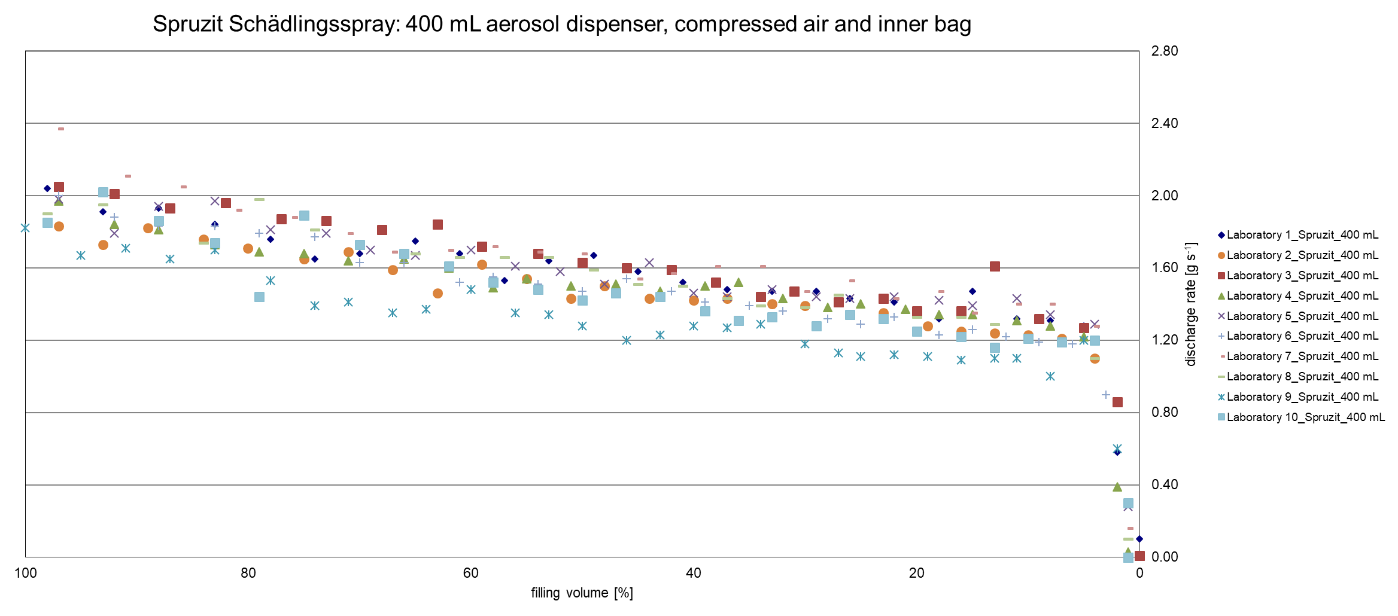

5.2 Results Protect Home Forminex Spezialspray
Lab No. | Temp. | Weight full dispenser (m_{f}) | Aerosol dispenser shaken? | Valve operated fully open for 5 s? | Operation time of valve during discharge rate test | Weight empty dispenser (m_{e}) | Mass of remaining liquid (m_{r}) | Mass of sample in filled dispenser (m_{s}) | Residue in Dispenser after Test  (R) | Results visual observations  (Report also disturbances of the spray cone, as well as any observations of crystallized material on the nozzle, nozzle blockage or leaks from the trigger head)
 | [°C] | [g] |  |  | [s] | [g] | [g] | [g] | [%]
1 | 24.9 | 194.5 | vigorously for at least 10 s by hand | Yes | 10 | 56.8 | 0 | 137.7 | 0.00 | no visual observations
2 | 25.3 | 207.8 | vigorously for at least 10 s by hand | Yes | 10 | 64.5 | 0.2 | 143.3 | 0.14 | During the determination, as the solution was sprayed for 10 seconds, it was observed that solution was wetting the finger that was pushing down the nozzle.
3 | 24 | 198.6 | vigorously for at least 10 s by hand | Yes | 10 | 56.9 | 0 | 141.7 | 0.00 | During spraying process no crystallized material on the nozzle was observed. No leaking from the spray head. The stated weights are without cover caps. Additional information: the pipe was attached to the nozzle!
4 | 21.1 | 195.5 | vigorously for at least 10 s by hand | Yes | 10 | 55.9 | 0.3 | 139.6 | 0.21 | weight always without cover and tube, Cone i.O, spray trials without tube, Nr. 7 during the 10s spraytrial: the dispenser will be empty, Nr. 8 dispenser empty, no further observations
5 | 21.7 | 196.9 | vigorously for at least 10 s by hand | Yes | 10 | 56.7 | 0 | 140.2 | 0.00 | From the second testing point there was a liquid film at the spray cone built by the drizzle.  After emptying the dispenser was opened. During opening a rest of propellant escaped. No liquid was in the dispenser.
6 | 25 | 197.2 | vigorously for at least 10 s by hand | Yes | 10 | 56.0 | 0 | 141.2 | 0.00 | Aerosol was empty at end of test 7. No disturbances of the spray nozzle, no crystallisation of material on the nozzle, no blockage or leaks of the spray head observed. 3mm drill bit used to pierce can prior to can being opened to allow any remaining propellant to escape. No remaining liquid observed. Interior of can inspected and found to be in good condition.
7 | 24.9 | 206.4 | vigorously for at least 10 s by hand | Yes | 10 | 64.7 | 0.2 | 141.7 | 0.14 | No problem. Additional information: the pipe was attached to the nozzle!
8 | 24.9 | 193.2 | vigorously for at least 10 s by hand | Yes | 10 | 57.5 | 0 | 135.7 | 0.00 | 'Minimal drops at the valve. After shaking a litle drop falling down.
9 | 24.9 | 191.7 | vigorously for at least 10 s by hand | Yes | 10 | 58.4 | 0.3 | 133.3 | 0.23 | -
10 | 24.9 | 198.4 | vigorously for at least 10 s by hand | Yes | 10 | 56.0 | 0.2 | 142.4 | 0.14 | Equilibration time: 45minutes (25°C ± 5°C); at record No. 7 no liquid was expelled after 4s valve operation; at record No. 9 the dispenser was empty. During test phase no disturbances of the spray nozzle and no crystallized material were observed respectively.

8 Laboratories performed test without pipe, 2 laboratories performed test with pipe plugged on spray nozzle
Spraying without pipe:
Laboratory No.: | 1 | 2 | 4 | 5 | 6 | 8 | 9 | 10 | Mean Discharge Rate | SD  Discharge Rate | RSD  Discharge Rate
Spraying operation  No. | Discharge Rate
 | [g/sec] |  |  |  |  |  |  |  | [g/sec] | [g/sec] | [%]
1 | 2.09 | 2.14 | 2.27 | 2.24 | 2.24 | 2.16 | 2.18 | 2.29 | 2.20 | 0.07 | 3.2
2 | 1.98 | 2.19 | 2.17 | 2.08 | 2.09 | 2.03 | 2.02 | 2.28 | 2.11 | 0.09 | 4.3
3 | 1.84 | 2.09 | 2.07 | 2.06 | 1.96 | 2.02 | 1.95 | 1.92 | 1.99 | 0.08 | 4.0
4 | 1.63 | 2.07 | 1.99 | 1.94 | 1.92 | 1.88 | 1.74 | 2.03 | 1.90 | 0.14 | 7.4
5 | 1.68 | 2.02 | 1.89 | 1.93 | 1.83 | 1.82 | 1.83 | 1.93 | 1.87 | 0.09 | 4.8
6 | 1.77 | 1.90 | 1.85 | 1.84 | 1.76 | 1.71 | 1.71 | 1.86 | 1.80 | 0.07 | 3.9
7 | 1.49 | - | 0.30 | 0.54 | 1.02 | 0.64 | 1.54 | 0.34 | 0.84 | 0.48 | 57
8 | 0.09 | - | 0.01 | 0.03 | - | 0.06 | 0.33 | 0.12 | 0.11 | 0.11 | 100
9 | - | - | - | - | - | 0.02 | 0.00 | 0.00 | 0.01 | 0.01 | 100
10 | - | - | - | - | - | 0.00 | - | - | - | - | -

Laboratory No. | 1 | 2 | 4 | 5 | 6 | 8 | 9 | 10 | Mean  Filling  Level | SD  Filling Level | RSD  Filling Level
Spraying operation  No. | Filling level
 | (F) [%] |  |  |  |  |  |  |  | (F) [%] | [%] | [%]
1 | 91 | 91 | 90 | 90 | 91 | 91 | 100 | 90 | 92 | 3.2 | 3.5
2 | 76 | 76 | 74 | 74 | 75 | 75 | 84 | 74 | 76 | 3.1 | 4.1
3 | 62 | 61 | 59 | 59 | 60 | 60 | 68 | 58 | 61 | 2.9 | 4.8
4 | 48 | 46 | 44 | 45 | 47 | 46 | 54 | 45 | 47 | 2.9 | 6.2
5 | 36 | 32 | 29 | 31 | 33 | 32 | 41 | 30 | 33 | 3.6 | 11
6 | 24 | 18 | 16 | 17 | 20 | 18 | 27 | 17 | 20 | 3.6 | 18
7 | 11 | - | 3 | 4 | 8 | 6 | 14 | 4 | 7 | 3.8 | 54
8 | 1 | - | 1 | 0 | - | 1 | 3 | 1 | 1 | 0.9 | 90
9 | - | - | - | - | - | 1 | 0 | 0 | 0 | 0.5 | -
10 | - | - | - | - | - | 0 | - | - | 0 | 0.0 | -
- not determined (spray can empty)
Spraying with pipe plugged on spray nozzle:
Laboratory No.: | 3 | 7 | Mean Discharge Rate | SD  Discharge Rate | RSD  Discharge Rate
Spraying operation  No. | Discharge Rate
 | [g/sec] |  | [g/sec] | [g/sec] | [%]
1 | 1.03 | 1.03 | 1.03 | 0.00 | 0.0
2 | 0.98 | 0.89 | 0.94 | 0.05 | 5.3
3 | 0.82 | 0.90 | 0.86 | 0.04 | 4.7
4 | 0.96 | 0.82 | 0.89 | 0.07 | 7.9
5 | 0.83 | 0.76 | 0.80 | 0.04 | 5.0
6 | 0.79 | 0.72 | 0.76 | 0.04 | 5.3
7 | 0.68 | 0.69 | 0.69 | 0.00 | 0.0
8 | 0.71 | 0.66 | 0.69 | 0.03 | 4.3
9 | 0.71 | 0.64 | 0.68 | 0.04 | 5.9
10 | 0.61 | 0.64 | 0.63 | 0.02 | 3.2
11 | 0.65 | 0.59 | 0.62 | 0.03 | 4.8
12 | 0.69 | 0.60 | 0.65 | 0.05 | 7.7
13 | 0.60 | 0.56 | 0.58 | 0.02 | 3.4
14 | 0.57 | 0.54 | 0.56 | 0.02 | 3.6
15 | 0.59 | 0.53 | 0.56 | 0.03 | 5.4
16 | 0.57 | 0.52 | 0.55 | 0.03 | 5.5
17 | 0.53 | 0.50 | 0.52 | 0.02 | 3.8
18 | 0.54 | 0.47 | 0.51 | 0.04 | 7.8
19 | 0.51 | 0.46 | 0.49 | 0.03 | 6.1
20 | 0.14 | 0.31 | 0.23 | 0.09 | 39
21 | 0.02 | 0.05 | 0.04 | 0.02 | 50
Laboratory No.: | 3 | 7 | Mean  Filling  Level | SD  Filling Level | RSD  Filling Level
Spraying operation  No. | Filling level
 | (F) [%] |  | (F) [%] | [%] | [%]
1 | 96 | 91 | 94 | 2.50 | 2.7
2 | 88 | 84 | 86 | 2.00 | 2.3
3 | 81 | 78 | 80 | 1.50 | 1.9
4 | 76 | 71 | 74 | 2.50 | 3.4
5 | 69 | 66 | 68 | 1.50 | 2.2
6 | 63 | 60 | 62 | 1.50 | 2.4
7 | 57 | 55 | 56 | 1.00 | 1.8
8 | 53 | 50 | 52 | 1.50 | 2.9
9 | 48 | 46 | 47 | 1.00 | 2.1
10 | 43 | 41 | 42 | 1.00 | 2.4
11 | 38 | 37 | 38 | 0.50 | 1.3
12 | 34 | 33 | 34 | 0.50 | 1.5
13 | 29 | 28 | 29 | 0.50 | 1.7
14 | 25 | 24 | 25 | 0.50 | 2.0
15 | 21 | 21 | 21 | 0.00 | 0.0
16 | 16 | 17 | 17 | 0.50 | 2.9
17 | 12 | 13 | 13 | 0.50 | 3.8
18 | 9 | 10 | 10 | 0.50 | 5.0
19 | 5 | 6 | 6 | 0.50 | 8.3
20 | 1 | 3 | 2 | 1.00 | 50.0
21 | 0 | 1 | 1 | 0.50 | 50.0
- not determined (spray can empty)

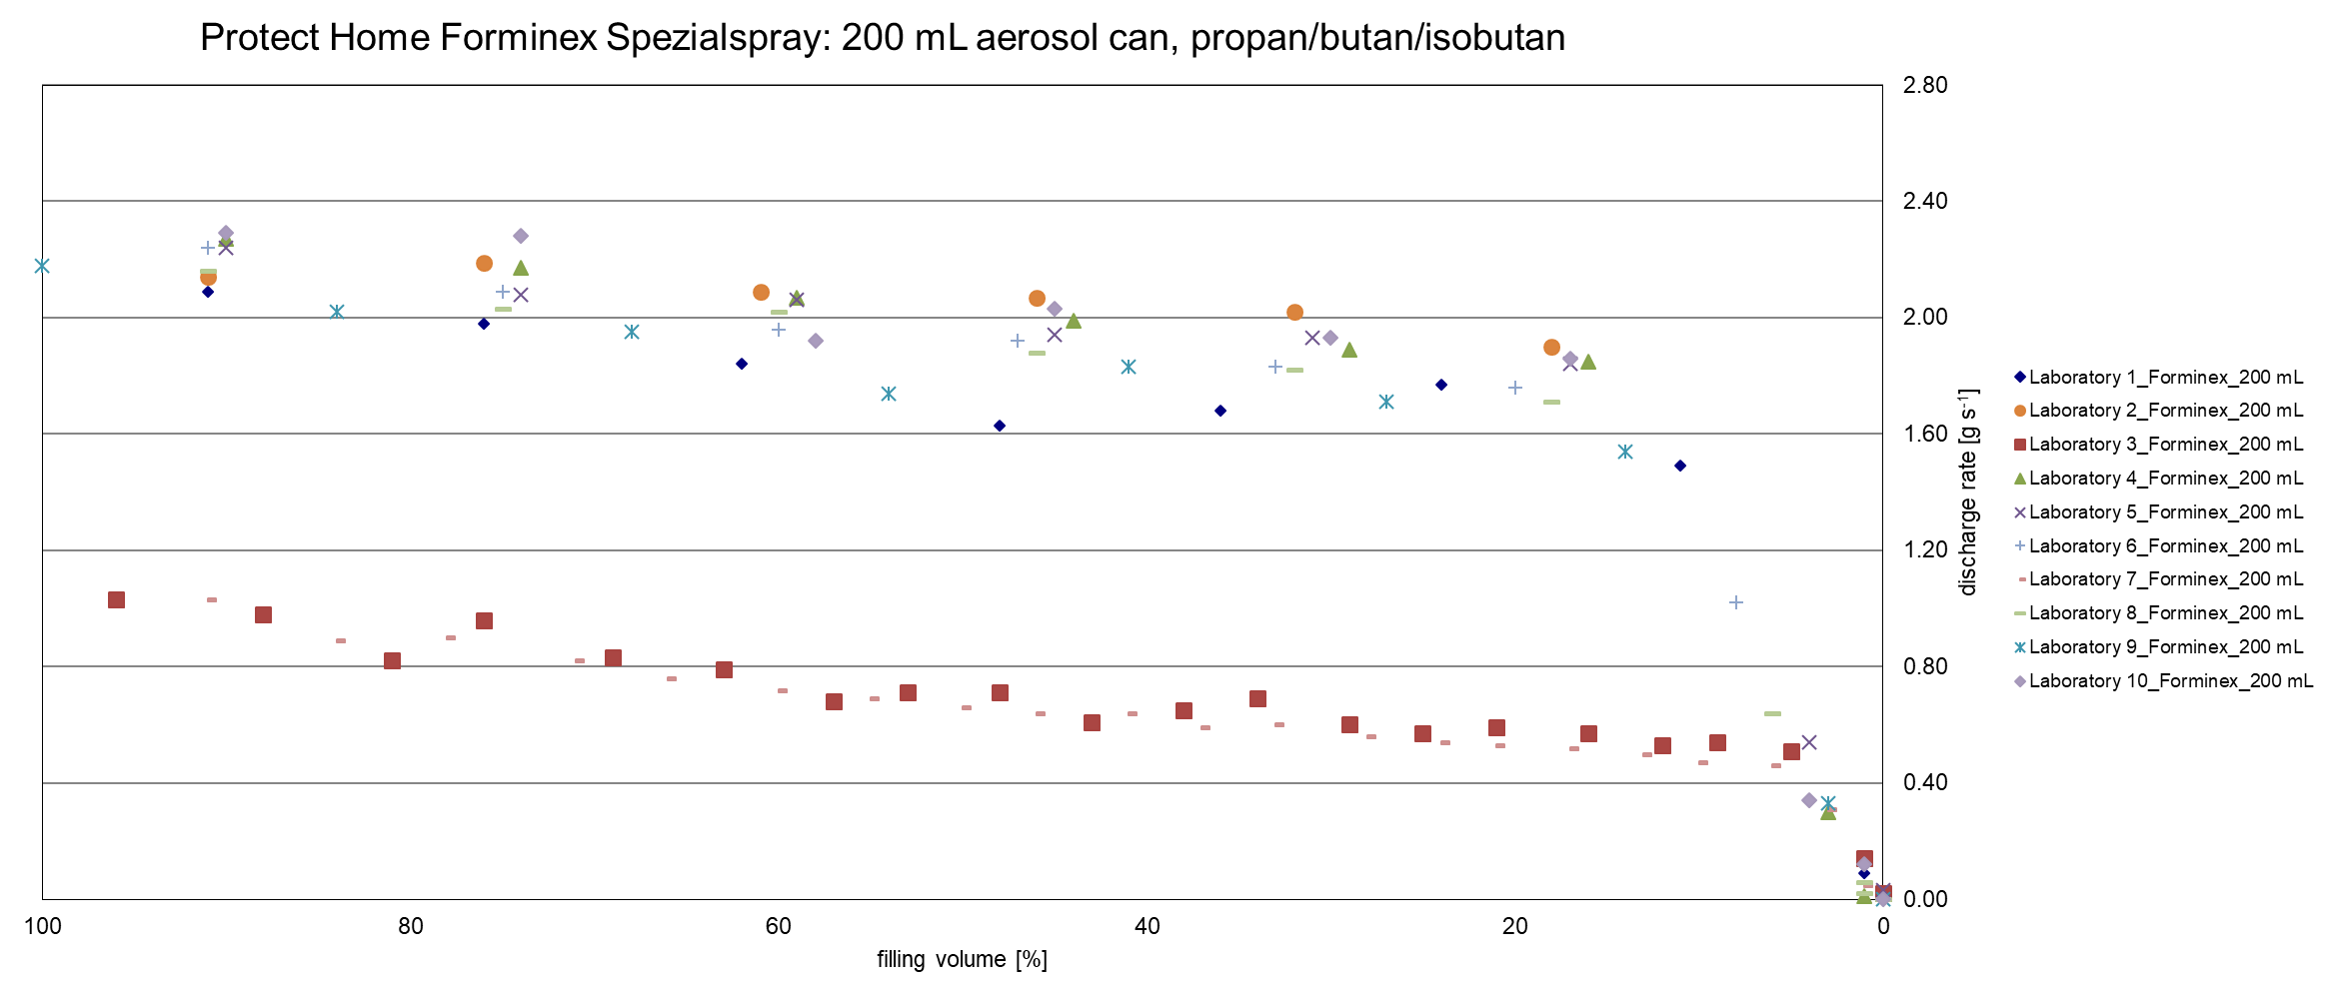

6 Evaluation of Results

6.1 Spruzit Schädlingsspray

- Results were received from all laboratories.
- All aerosol dispensers were equilibrated at 25 ± 5 °C. The temperature range was 20 °C to 25.06 °C.
- All aerosol dispensers were shaken vigorously for at least 10 s by hand.
- The weights of the full dispenser were determined.
- Before starting the discharge rate determination, the valves of the dispenser were operated fully opened for 5 s.
- The masses of the dispenser before and after spraying for 10 s was determined to the nearest 0.1 g.
- Spraying procedure was repeated by all laboratories until the dispenser was empty.
- The weights of the empty dispensers were determined by all laboratories.
- The mass of sample in the filled dispenser was calculated to the nearest 0.1 g.
- The discharge rate depends on the filling level.
- Down to a filling level of 11 % the discharge rates between the laboratories were comparable.
- The relative standard deviation of discharge rate was in the range of 4.3 to 9.7 % at mean filling levels of 98 to 11 %.
- The relative standard deviation of filling level was in the range of 0.9 to 44 % at mean discharge rates of 1.98 to 1.25 %.
- The spray cone was visually inspected for disturbances of the spray cone, crystallized material on the nozzle, nozzle blockage or leaks from the aerosol head. Two laboratories provided no visual data. One laboratory observed non-continuous spraying for a short period.

Summary:
The discharge rate was determined by 10 laboratories.
The discharge rates determined by laboratory 9 were slightly lower than discharge rates determined by other laboratories. The results of discharge rates determined by laboratory 9 showed according to Grubbs test 4 outliers (P = 99 %) of 23 spraying operations performed at mean filling levels of 98 to 11 %. All things considered laboratory 9 is not an outlier.
The results showed good conformity and demonstrate the robustness of the method.

6.2 Protect Home Forminex Spezialspray

- Results were received from all laboratories.
- Two laboratories used the spray-pipe. Eight laboratories performed the test without spray-pipe.
- All aerosol dispensers were equilibrated at 25 ± 5 °C. The temperature range was 21.1 °C to 25.3 °C.
- All aerosol dispensers were shaken vigorously for at least 10 s by hand.
- The weights of the full dispenser were determined.
- Before starting the discharge rate determination, the valves of the dispenser were operated fully opened for 5 s.
- The masses of the dispenser before and after spraying for 10 s was determined to the nearest 0.1 g.
- Spraying procedure was repeated by all laboratories until the dispenser was empty.
- The weights of the empty dispensers were determined by all laboratories.
- The mass of sample in the filled dispenser was calculated to the nearest 0.1 g.
- The discharge rate depends on the filling level.
- Down to a filling level of 20 % the discharge rates between the laboratories were comparable.
- The relative standard deviation of discharge rate of 8 laboratories (test performed without spray-pipe) was in the range of 3.2 to 7.4 % at mean filling levels of 92 to 20 %.
- The relative standard deviation of filling level was in the range of 3.5 to 18 % at mean discharge rates of 2.20 to 1.80 %.
- The relative standard deviation of discharge rate of 2 laboratories (test performed with spray-pipe) was in the range of 0.0 to 7.9 % at mean filling levels of 94 to 6 %.
- The relative standard deviation of filling level of 2 laboratories (test performed with spray-pipe) was in the range of 0.0 to 8.3 % at mean discharge rates of 1.03 to 0.49 %.
- The spray cone was visually inspected for disturbances of the spray cone, crystallized material on the nozzle, nozzle blockage or leaks from the aerosol head. One laboratory provided no visual data. Three laboratory observed drops at the valve.

Summary:
The discharge rate was determined by 10 laboratories.
Two laboratories performed the test using the spray pipe. Due to higher back-pressure the discharge rates of these trials were lower than discharge rates determined without pipe. Both results are congruent.
Eight laboratories not used the spray-pipe. Results of discharge rates were congruent. No outlier was observed.
The results showed that the method can distinguish between different use modes.
The results showed good conformity and demonstrate the robustness of the method.

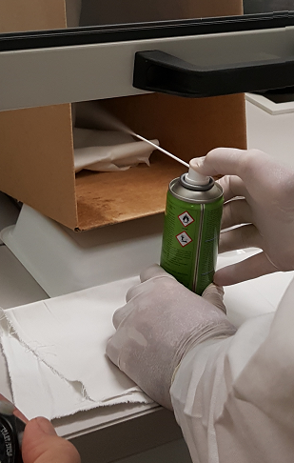
Figure 1: Spray-pipe was used by laboratory 3 and 7, photo provided by laboratory 3

7 Conclusion and Recommendation
The results of the collaborative trial demonstrate the applicability and robustness of the proposed method to determine the discharge rate of Aerosol Dispenser. The measurement uncertainty of the method in terms of reproducibility (RSD_{R}) is with ≤ 9.7 % acceptable.
- Spruzit Schädlingsspray: no outlier was detected.
- Protect Home Forminex Spezialspray: no outlier was detected.
DAPF recommend that the proposed method is adopted as provisional CIPAC Method.

